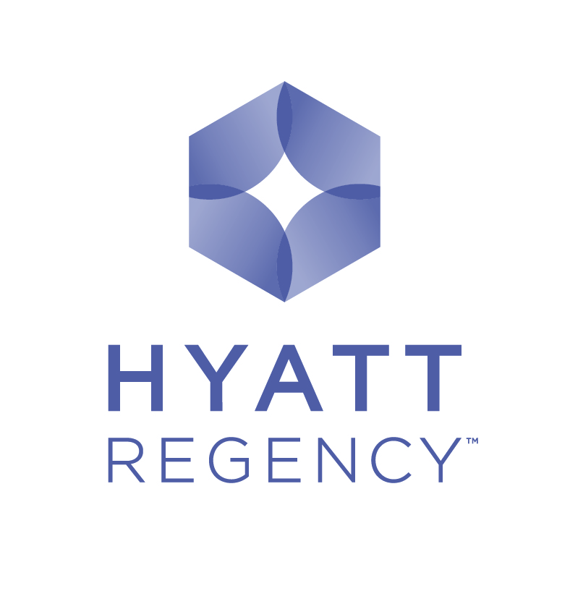

Reservation Form
Hyatt Regency Belgrade looks forward to having you as a guest during the

“Serbian-Slovenian business forum”

(Belgrade, October 24-25, 2014)

This reservation form should be used to secure a room. Should you require a room outside the dates, hotel’s Reservations Department will advise you of availability and rates. The cut-off date is October 19, 2016. All reservations after October 19, 2016 will be accepted subject to availability at the best rate available at that time. Listed below are the current best prices for Serbian-Slovenian business forum participant’s accommodation.
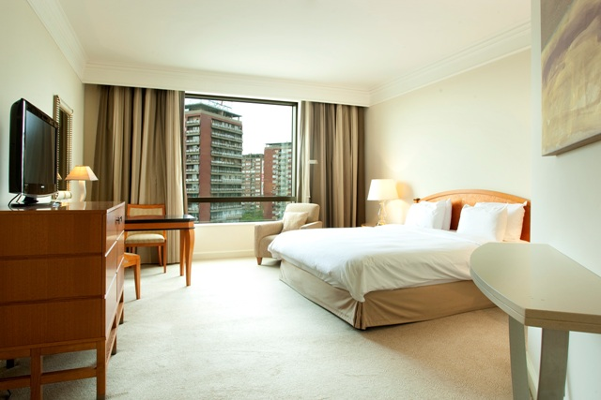
Number of rooms/suites under bellow proposed special rate is limited.

Room requirements (please tick)
King Room (38sqm) EUR 80
Twin Room (38sqm) EUR 80
Deluxe Room (53-56sqm) EUR 110

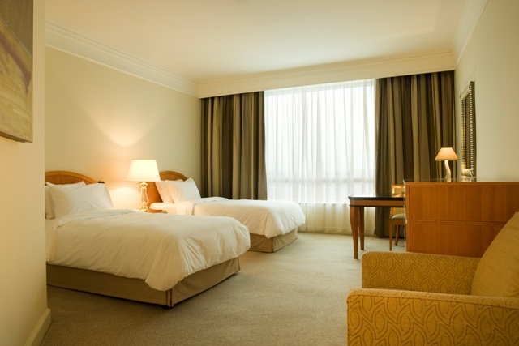
Special rates available for higher category rooms (Club rooms and Suites)
Room requirements (please tick)
Club King Room (38sqm) EUR 140
Club Twin Room (38sqm) EUR 140
Regency Suite King (66sqm) EUR 230

Particular Requirements: (Smoking/Non Smoking)

Rates are per night (single occupancy) including breakfast and internet, and excluding VAT (10%) and tourist tax (EUR 1, 5 p.p.). Note that VAT and tourist tax amount is subject to change.
Supplement for second person is EUR 15.

For all guest accommodated use of the Olympus Fitness Club (swimming pool, sauna, gym and whirlpool) is complimentary.

Name: Company: Position/Title:
Address: City: Post Code:
Country: Telephone: Fax: E-mail:

Credit card number:
Expiration date: Signature:

Arrival & Departure
Arrival Date: Departure Date:
(Check-In Time After 15:00) (Check-Out Time Before 12:00)

Reservations are only acceptable by sending this form completed to Hotel reservation department (contact details listed bellow). No reservations will be confirmed nor guaranteed unless credit card details are supplied.
Hyatt chain is fully in compliance with Payment Card Industry standards, due to which we kindly ask you to provide your credit card information by telephone after sending this reservation form or completing the authorization form attached.

Any cancellation of or amendment to a confirmed reservation must be received by the Hotel in writing latest by 3:00 pm Belgrade time one day before arrival. Failure to do so or guest no-show will result in a cancellation fee due from the guest to the Hotel in the amount of one night charge.

Airport Pick-up / Drop-off
Airport transfer is available by hotel car at EUR 27 per way, per car. Should you wish to make a reservation of hotel’s shuttle bus, please fill in the following details:
Arrival Flight Details: Departure Flight Details:

Please send this form to the attention of: For hotel Use

Hyatt Regency Belgrade Confirmation Number:
Reservation Department
Milentija Popovica 5, 11000 Belgrade, Serbia ROOM BLOCK: SPKL
Telephone: (381) (11) 301-1234 Comments: _____________________________
Fax: (381) (11) 311-2234 ________________________________________
E-mail: reserve.hrbelgrade@hyatt.com

Please note that any changes made to your reservation have to be notified in writing to the hotel.

